For the MOS transistors in the circuit shown in Figure-1, μ_{n}C_{ox}=2μ_{p}C_{ox}=20μA/V², β_{n}=μ_{n}C_{ox}(W_{n}/L_{n})=100μA/V² (that is W_{n}/L_{n}=5), V_{t-n}=1V, V_{t-p}=-0.7V, V_{An} = V_{Ap} = 50V are given.

a) Vo=2.5V is required in DC case when Vi=2.5V. Find the aspect ratio (W_{p}/L_{p}) of PMOS transistor (β_{p}=μ_{p}C_{ox}(W_{p}/L_{p})).(10Points)
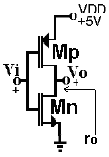

From the circuit: Vi=VG1=VG2=VD1=VD2=2.5V
If VG=VD, an enhancement type MOS transistor is in the saturation region.
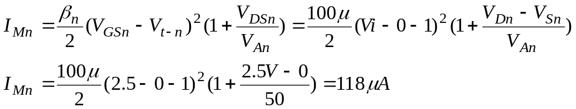

From the topology: I_{Mn}=I_{Mp}

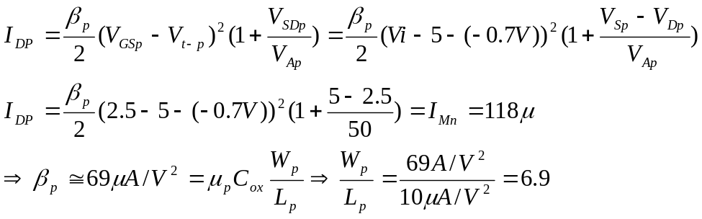

b) Find ac gain (νo/νi). (10Points)
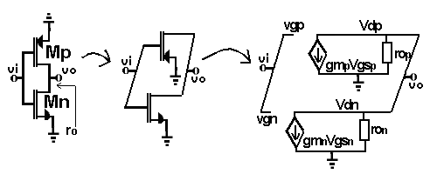
ac case of the circuit

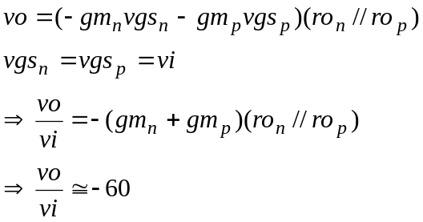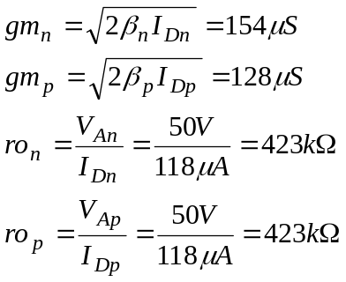

c) Find ac output resistance of the circuit. (5Points)
